--------------------------------------------------------------------------Day1-----------------------------------

# DIAGRAMS:

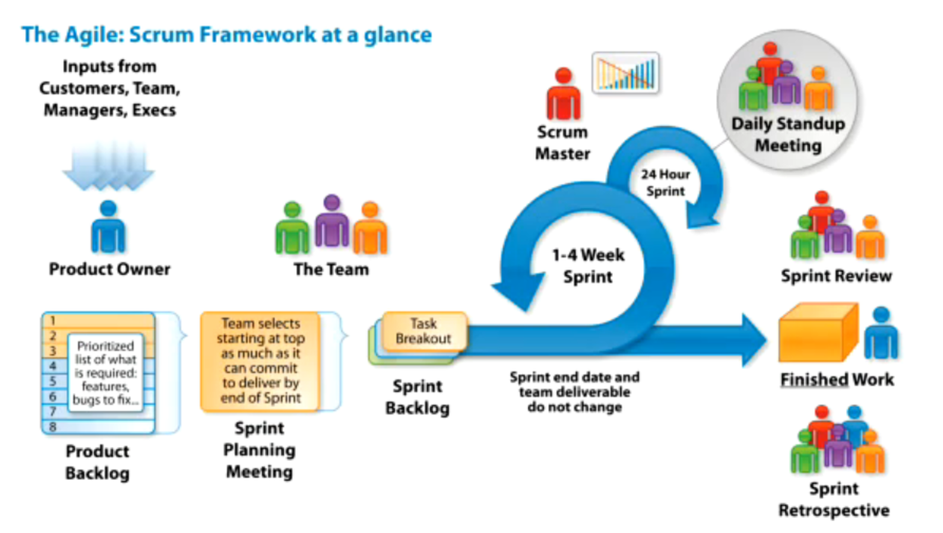

**JIRA Backlog Board**

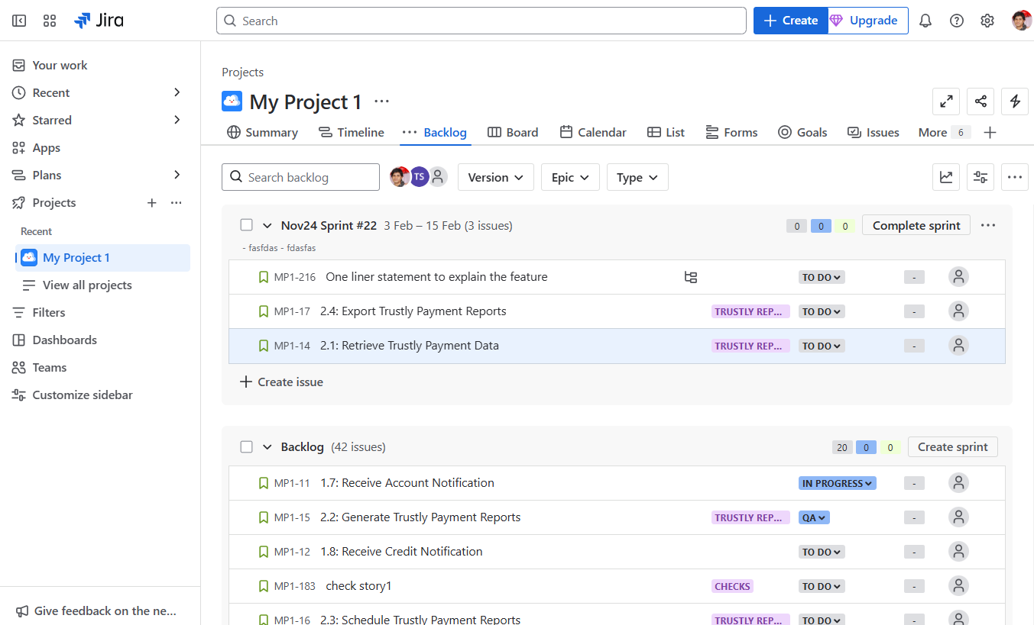

**Sub Task creation**

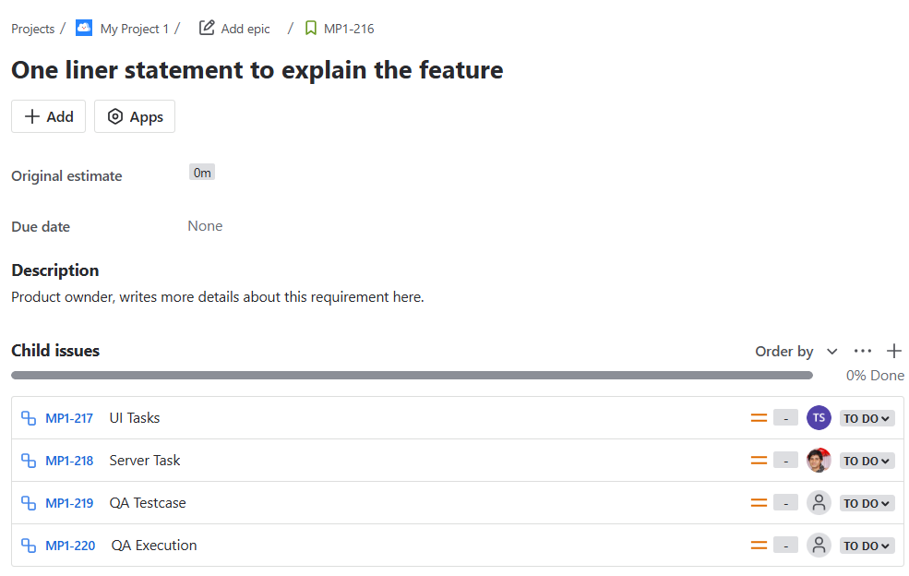

**Ongoing Sprint board**

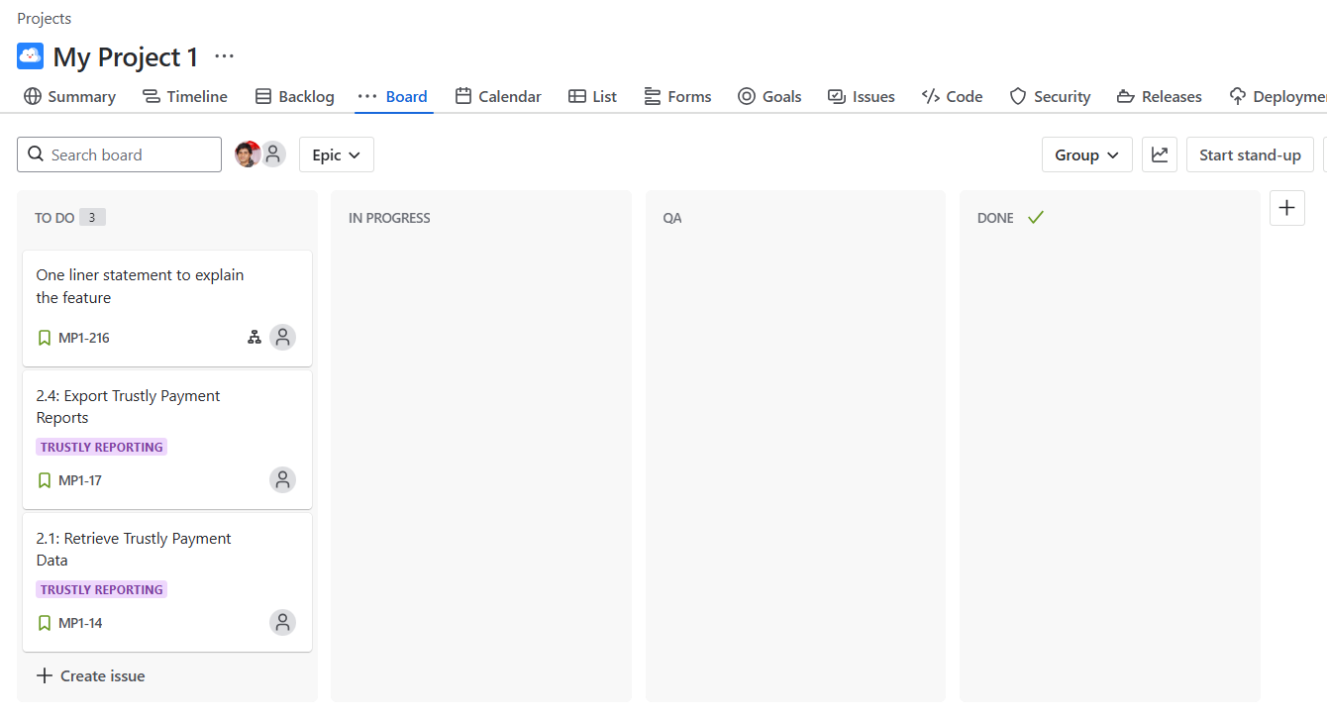

# LIVE notes:

We will start at 10:00 AM.

Day1 - Getting Started.

Please mark poll!!!

-----

Tausief Shaikh

2010/2011

14-15yrs of IT exp

java dev

full stack - js, angularjs, aws

4-5 members

Tech Lead

Engg Manager - 15+ members

Senior Manager

Head of Technology (40member team)

product, service

MNCs

startup

0-2yrs of IT professionals

2 months internship. Fresher -

Problems and Solutions

Problem: People are struggling to get jobs in IT.

Solution: How to get a job as quickly as possible.

1.5yrs. many jobseekers got job by applying the techniques that we will discuss.

Solving all issues, why people are not able to get interview calls. How you will guaranteed get calls & how you will crack the interview.

Companies Say: We need good people. Hire. Candidates Say: First hire us, then only we will become good.

*Fresher:*

1. Candidates with internship experience

2. Candidates with good project

3. Regular candidate - mini project with basic skills

4. Only tech skills. Java

Value of TIME.

Realtime Projects: More knowledge & more skills you would know.

B**ackend Developer: Java, Java Spring Boot & Microservice**

Roadmap.sh: Have good knowledge, then opportunity comes.

**https://roadmap.sh/**

Have good knowledge, then opportunity comes.

Discuss all this MUST have knowledge as part of this internship.

2 Parts: Mon-Fri, 10AM - 2/3hrs

Part1:

Week1: How can you get job quickly.

Part2:

From Week2 continue with internship.

**Week1: How can you get job quickly.**

- End-to-end working process of IT (java backend)

- Software / tools MUST have.

- You should have these skills in your resume.

- Technical discussions

Rest API using Spring Boot

Deploy & test in AWS

in local machine itself you practice

test in local

vs

test in AWS

- SDLC - Agile - Scrum

- Project management - Jira

- Rest API using Spring Boot

- IDE (Eclipse, STS, IJ, VSCode)

- Postman

- AWS deployment & Testing (Azure, GCP, )

- Mandatory Linux knowledge

- Workign with Version control - Git + BitBucket

Branching (master, integration, feature, release, bug branch, hotfix)

dev env, qa, uat, prod

Logging: SLF4J with Logback, ELK stack

Unit testing + Mocking + Code Coverage: Junit + Mockito

Build tools: Maven

**I will mentor you, so you can take action. whatever problem you are facing, you need to solve it by yourself using internet. Logical thinking. AI.**

- How to arrange interview calls.

- How to crack interview calls.

- Efficient resume

**https://resume.naukri.com/resume-quality-score**

Belongs in top 3% of all profiles of Naukri.

Week2: Rest of the Internship will continue.

Wednesday (Day3: 5Feb)

Payment Integration Project

**https://docs.stripe.com/payments/checkout/how-checkout-works**

**2months**

Week1: To get Job in IT.

1.5yrs - 2yrs (2023)

**Desire**

**Belief**

**Action**

**Result**

**----------------**

**Consistently**

**----------------**

**I PROMISE TO MYSELF THAT I WILL GET JOB.**

**I STRONGLY BELIEVE IN MY ABILITIES TO SUCCED.**

**I HAVE STRONG DESIRE TO GET JOB, AND STRONG BELIEF THAT I WILL GET JOB**.

=========

How IT projects are built

SDLC (Software development life cycle)

PLC

From start till end, how the software is built

**Agile** - approach of software development.

Scrum model

- Kanban

- Scrumban

**Agile is**

**"Timebox based iterative approach of software development"**

Older models of software dev- - waterfall, spiral

for(i=0; i <= 10; i++) {

...

..

..

}

Timebox - 1 week, 2 weeks, 3 weeks, 4 weeks

1-4 weeks

Time frame: Sprint

Meetings

1. Refinement/Grooming/Requirement gathering meeting

requirements will be discussed with tech team.

what needs to be developed.

tech team will ask questions & get clarification

2. Sprint planning meeting

- Day1 of the sprint

- team decides how many features we can finish as part of this sprint

- Don't count weekends. 9hrs work

2weeks--- heavy coordination between

Multiple developers

FB / BE

QA

DevOps

DBA

long process

3. Daily Standup meeting (Scrum)

- Every day at beginning of the day.

- every team members is supposed to give their status update.

- What you were doing yesterday

- what is your plan for today

- are we on track to finish the work

- do you need support from other members.

4. Sprint review / Sprint demo

- happens at end of sprint

- you give demo to the client of what features are developed in that sprint.

- show database, show logs, execute the features & explain end-to-end.

5. Retrospective meeting

- Learn from your last sprint.

- discuss what problems happened in the sprint

- discuss how can you solve those problems.

- what went right

repeat in next sprint

- what went wrong

don't do again. improve

- new initiatives

=======

**Agile:**

**3 bullet points**

• **Iterative Development**: Agile focuses on delivering work in small, manageable increments called iterations or sprints. This allows for continuous feedback and adjustments, ensuring that the final product meets user needs and expectations.

• **Collaboration and Communication**: Agile promotes close collaboration among team members and stakeholders. Daily stand-up meetings, regular reviews, and continuous communication help identify and resolve issues quickly, fostering a transparent and cooperative work environment.

• **Flexibility and Adaptability**: Agile methodologies emphasize the ability to respond to change. Teams are encouraged to adapt their plans based on new information or changes in requirements, ensuring that the project remains aligned with business goals and user needs.

Sprint - 2weeks

Sprint planning meeting - daily standup - demo - retro

Internship Completion

Daily Attendance - Demo

### Key Roles/Designations in Agile

* Product Owner (PO)
* Scrum Master (SM)
* Team (Architect, Tech Lead, etc.)

**Client => Product Owner => Tech Team**: Write the requirements.

**End-to-End Project Management Tool**:

* Jira
* Asana, Planning

Atlassian Jira - Create account here

* Agile => Software development => Scrum project

https://www.atlassian.com/software/jira (Create account here)

Agile => software development => (Scrum project)

Every team member has access to Jira.

PO / product / product owners

SM

each team member will have account in Jira.

- In Jira backlog(product backlog) section, all upcoming functional requirements will be there.

- the features will be available in backlog, as priority list. tech team, is supposed to pick the items for development, from top of this priority list.

========

### Using Jira

1. PO logs into Jira & writes the requirement.
2. Requirements written as User stories. Each story has a unique ID (Ticket: Story/task/bug).
3. Arrange in priority.
4. Get in grooming meeting - Calendar.
5. Clarification & update to requirement.
6. Jira should reflect the final state of requirement.
7. 3-4 features discussed in refinement meeting.
8. Sprint planning meeting.
9. Who will work on which feature? Task breakdown & work allocation:
   * Create child subtask for your user-story.
   * Assign the right subtask to the right person.
10. Start the sprint and select the sprint duration.

### Technical Skills and Tools

* REST API using Spring Boot
* AWS (Linux)
* Version control (Git + BitBucket)
* Logging: SLF4J with Logback, ELK stack
* Unit testing + Mocking + Code Coverage: Junit + Mockito
* Build tools: Maven

Agile-Setup your jira account

--------------------------------------------------------------------------Day1-----------------------------------